**University of Petroleum and Energy Studies**

School of Computer Science

Department of Cybernetics

**Graphics & Animation Tools**

**LAB FILE**

**(Session: 2020-2021)**

Course: B. Tech with Specialization in Open Source and Open Standards

Submitted To- Submitted By-

Dr. Durgansh Sharma Kunal Ojha

Associate Professor SAP ID -500063333

Department of Cybernetics Roll No. -R100217034

**Experiment 7-** Design of 3D Car using Blender.

Google Drive Link- <https://drive.google.com/drive/folders/1U6jVGEc-PTqf4SeEXvlP9rMzlCHzSqOx?usp=sharing>

Step 1- Open blender and select new file type as general

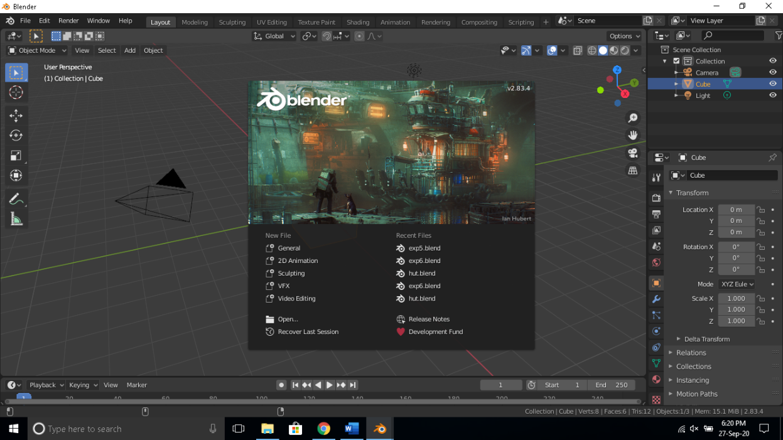

Step 2-In layout mode click on add select mesh and click on cube adjust the size of cube using scale tool and go to modelling tab and add loop cuts so that you can shape the cube into the body of a car.

Step 3- Use the bevel and extrude tool in modelling to model the cube into the following shape.

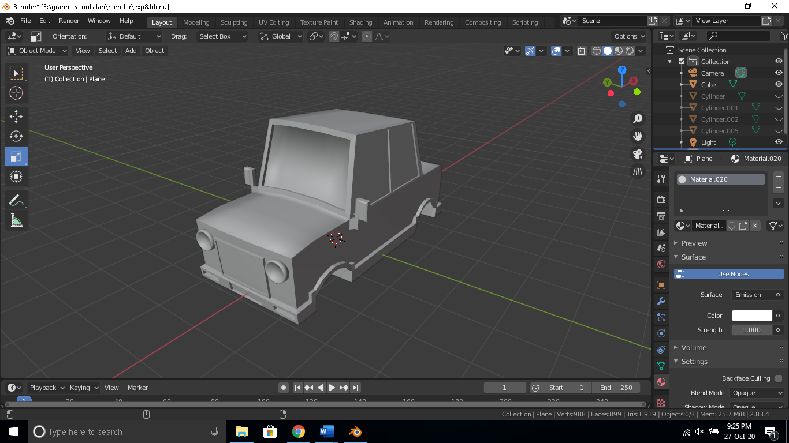

Step 4- Add a cylinder on the side of the main body and bevel it to make it look like wheel as shown below.

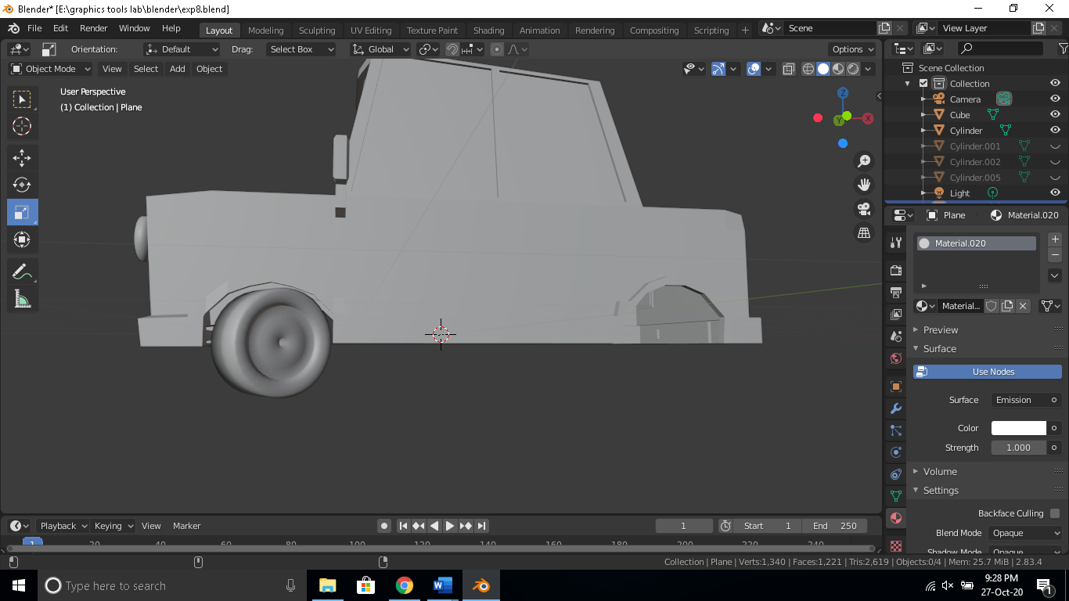

Step 5- Copy the cylinder mesh so that we have four wheels and position them as shown below.

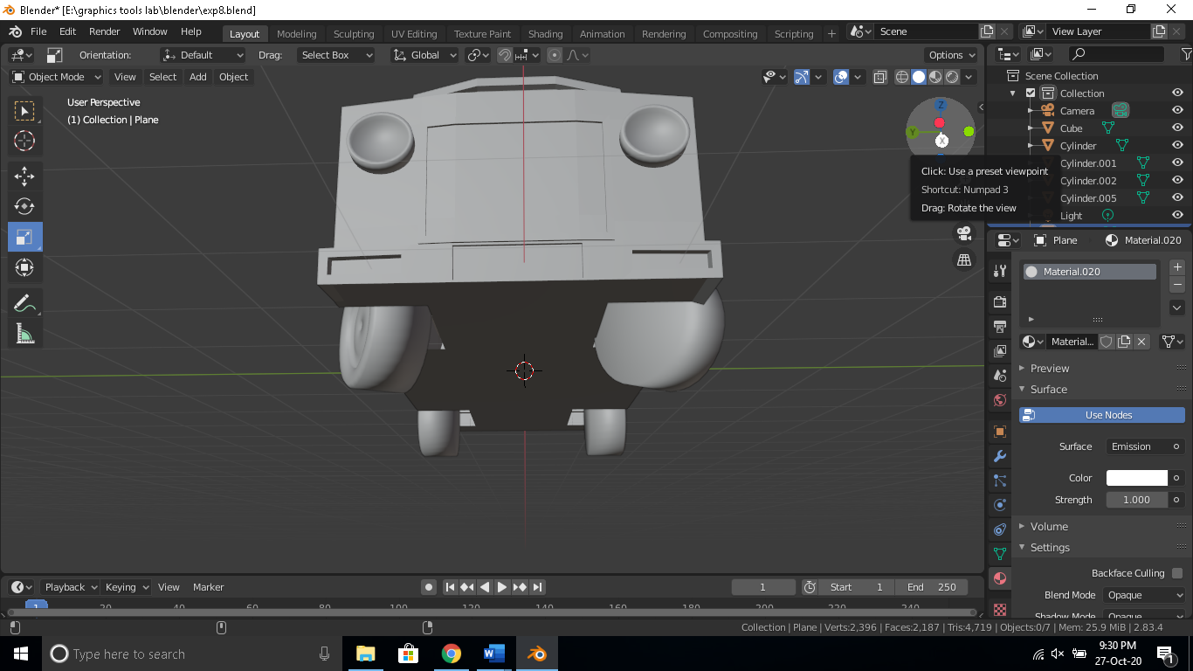

Step 6- Apply color to each surface as suitable and render the output image.

